1. **Background of Apple**

Apple Inc., originally Apple Computer, Inc., is an American technology company that was founded in 1976 by Steve Jobs, Steve Wozniak and Ronald Wayne that creates, manufactures, and sells smartphones, tablets, wearables, and accessories, as well as a number of connected services. It was the first successful personal computer firm, and the graphical user interface was popularized by it. Cupertino, California is home to the company's headquarters. Today, Apple is the world's most valuable firm and the world's largest technology company by sales which totals at approximately $274.5 billion in fiscal year 2020. It is also one of the largest manufacturers in the world for both smartphones and laptops as of 2021. Along with Amazon, Google, Microsoft, and Facebook, it is one of the Big Five American information technology businesses currently in existence.

The iPhone, Mac, iPad, Wearables, Home, and Accessories are among the company's goods. The iPhone is Apple’s series of mobile phones that run on the iOS operating system. Macs are Apple’s range of computers which run on the patented macOS operating interface. Wearables and accessories that Apple currently manufactures include the likes of AirPods, Apple TV streaming boxes, Apple Watches etc. Services that Apple offers include AppleCare, Cloud Services, Digital Content, and Payment Services. Apple’s clients are mostly everyday basic consumers, small and medium-sized enterprises, education, and government sectors of the market.

We are focusing mainly on the iPhone during this project. The iPhone was originally announced by the CEO of Apple Steve Jobs in 2007. The iPhone is one of the best selling gadgets and smartphones, selling a total of more than 2 billion iPhones in 2019. The iPhone was an industry innovation, with it removing the majority of the buttons on cell phones which was a common sight in the past.

To date, Apple has released 12 series and 29 iPhone models, and is one of the top 5 smartphone companies, with its competitors being Samsung, Xiaomi, and HuaWei.

1. **Understanding of the data**

Net revenue, profit and profit margin (2005 - 2020)

| **Name** | **Description** | **Data Type** |
| --- | --- | --- |
| Date | Date of each year. | Whole Number |
| Net Revenue | Net revenue of Apple for each year. | Currency |
| Net Income/Profit | Net profit of Apple for each year. | Currency |
| Profit Margin | Net Profit Margin of Apple for each year. | Decimal Number |

Revenue by Product Sales (1Q 2012 - 1Q 2021)

| **Name** | **Description** | **Data Type** |
| --- | --- | --- |
| Date | Date for each quarter of the year | Date |
| Product | The category and type of product being sold. | Text |
| Revenue | The revenue earned for each product during the specific quarter and year. | Currency |

Revenue by Region (1Q 2015 - 4Q 2020)

| **Name** | **Description** | **Data Type** |
| --- | --- | --- |
| Date | Date for each quarter of the year | Date |
| America | The revenue earned in America during the specific quarter. | Currency |
| Europe | The revenue earned in Europe during the specific quarter. | Currency |
| Greater China | The revenue earned in Greater China during the specific quarter. | Currency |
| Japan | The revenue earned in Japan during the specific quarter. | Currency |
| Rest of Asia Pacific | The revenue earned in the rest of Asia Pacific during the specific quarter. | Currency |

Smartphone Shipments by Quarter (Q1 2018 - Q1 2021)

| **Name** | **Description** | **Data Type** |
| --- | --- | --- |
| Quarter | Date for each quarter of the year. | Date |
| Shipments | Number of shipments made by each brand of smartphone by each quarter. | Whole Number |
| Brand | The brand of smartphone | Text |
| Market Share | Market share of each brand of smartphone by each quarter. | Whole Number |

Smartphone Penetration Rate by Country (2017 - 2020)

| **Name** | **Description** | **Data Type** |
| --- | --- | --- |
| Country | Name of the country | Text |
| Year | Year for each country and penetration rate | Whole Number |
| Penetration rate | Penetration rate for each country by year | Percent |

Number of cities in which 5G is available by country (2021)

| **Name** | **Description** | **Data Type** |
| --- | --- | --- |
| Country | Name of country | Text |
| No. of cities | Number of cities in the country with 5G | Whole Number |

1. **Cleaning of Data**

The practice of correcting or deleting incorrect, corrupted, improperly formatted, duplicate or incomplete data from a dataset is known as data cleaning. Furthermore, there are numerous ways for data to be duplicated or mislabeled by merging various different data sources. If we do not clean our data, our analysis will be unreliable at best. Therefore, it is important to check datasets for any errors or inconsistencies for cleaning so that the level and quality of analysis is at the highest possible.

Because methods will differ from dataset to dataset, there is no one-size fits all approach to prescribing the exact phases in the data cleaning process. Therefore, it is critical to create a template for your data cleaning procedure so you can be sure you're doing it correctly every time.

As we compiled data from multiple sources such as Statista, Apple’s own annual financial statements, reports and other online sources, we had to ensure that corresponding data and categories correlated and were accurate with one another. Thus, statistical figures such as revenue and sales had to be cleaned as some sources provided values in millions, others in billions, and some in thousands. Hence we had to find a common denominator and ensure that the numbers corresponded, and were accurate.

Another data segment that required cleaning was the dates. As some sources provided the data by quarter, and others by date. So we also had to change and ensure that all the date data formats were consistent throughout the spreadsheet. Hence, for those that were categorised by quarter and worded in text, we had changed to a date format by inputting the date of the last day of the specific quarter. This way, we ensured that our visualizations on the business intelligence softwares would have a consistent form for all the tables and values that included the date.

1. **Business Question and 3 Visualisations**

**Business Question :** How have Apple’s iPhone sales been performing and which regions are most likely to still have space for growth?

Apple iPhones are Apple’s flagship product that generates the most revenue out of all the products that Apple offers. With their continuous improvement and release of new iPhone models every few years, Apple has managed to stay highly competitive in the smartphone market. Thus, we have created 4 dashboards to analyze the details of iPhone sales and drill down to find out in which region Apple can put more focus in expanding.

**4.1 Revenue by Product Sales**

In this dashboard, we looked at the revenue Apple generated by year and product (refer to **Appendix A**). The total accumulated revenue of Apple is 2 trillion USD, as shown by the card visualization, and the donut chart shows the total revenue of each product type from 2012-2021. We have used an area chart and a stacked bar chart to obtain visuals of the overall sales performance of the different products offered by Apple through the years. Both charts can be drilled down to quarterly levels to view the breakdown of quarterly earnings in a chosen year.

From this dashboard, we can see that the iPhone is the top performing product by Apple. iPhones make up 64.99% of their all time sales, a far cry from their second best performing product type, Apple Services, which forms 14.71%. This shows that iPhones are evidently Apple’s best product. Analysing the area chart, we can see that iPhone sales experienced a large growth since 2012, peaking at 2015 and 2018. Despite experiencing mild fluctuations from 2015-2020, their sales levels remain relatively stable. The other product types offered by Apple, being Services, Mac and Wearables, home and accessories, experienced slow and steady growth throughout the years, without any notable fluctuations.

However, a downward trend was observed after 2020. On drilling down, we can see that sales for every product type experienced a sharp drop in April, the second quarter of 2020, and stayed low for the remaining quarters as well. This can be likely attributed to the Covid-19 pandemic that affected the entire globe. April was when the pandemic first caused lockdowns in many countries around the world. The economy was largely affected, and has still yet to recover in 2021. Various companies laid off staff and jobs are becoming hard to come by. This could likely have contributed to weakened consumer spending, where consumers became more cautious of their capital expenditure, and redirected their money toward essential items.

**4.2 Smartphone Shipments by Quarter vs Competitors**

In this dashboard (**Appendix B**), we look at the brands in the smartphone industry to understand Apple’s competitors better. This will also enable us to see how competitive the iPhone is against other smartphone brands. Data on average market share by year and brand from 2018-2021 and shipment numbers by brand were used as points of analysis. To analyze market share, we have used a line chart and stacked column chart to visualize the change each brand experienced over the period of 4 years. The visualizations can be drilled down to quarterly levels in a chosen year. A treemap and pie chart were used to show the shipment (in millions) by brand.

From the line chart, we can see that in 2018, Samsung was the brand with the largest percentage of market share by average at 20%, and has stayed as the brand with the largest percentage of market share. A notable growth was observed in 2020. This is likely related to Samsung’s release of a collaboration smartphone with Korean pop group BTS, that was sold out within an hour of release. The success in boosting sales is reflected in their market share, as presently in 2021, they are the brand with the biggest market share in the industry at 22%, overtaking even the smaller brands combined.

Apple and Huawei were closely competitive as the brands with the second largest market share from 2018 until 2020. However, in 2020, Huawei saw a sharp and drastic drop in market share, and fell from second place at 15% to sixth place at 4%. This is a highly unusual observation for a company that was considered one of the forefront contenders of the smartphone industry. Drilling down, we can see that the drop occurred in April, the second quarter of 2020. Upon further research, we have discovered that this could have been caused by the finalization of the US Huawei ban, stopping companies from the US in working with the Chinese brand. This caused a major change in the smartphones that Huawei rolled out, resulting in poor sales outside of its home country. Compared to its top two competitors, Apple’s market share remained stable without much changes. As of 2021, due to Huawei’s drop in market share, Apple has comfortably taken over as the brand with the second largest average yearly market share at 17%.

**4.3 Revenue by Date and Region**

In this dashboard (**Appendix C**), we analyse the net revenue, profit and profit margins of the iPhone in America, Europe, Greater China, Japan, and the rest of the Asia Pacific. This dataset spans from 2005 to 2020 and provides us valuable insight into which regions the iPhone is performing the strongest and weakest in. Based on that, we can understand which regions are likely to still have opportunities for growth. In order to analyse the iPhone’s revenue by date and region, we first used a line and clustered column chart to visualise how the overall net profit and revenue of the iPhone has grown from 2005 to 2020 in relation to the profit margin. Secondly, we used a ribbon chart to visualise how the different regions have performed in relation to one another in terms of hierarchy by revenue over the years. Thirdly, we used a donut chart to visualise in depth how the different regions have contributed to revenue overall. Lastly, we used a box and whisker plot to explore in depth variations in profit margin over the years.

From the line and clustered column chart, we observed that net profit, net revenue and profit margin grew in tandem up until 2013, where the profit margin fell from its peak at 26.66% in 2012 to 21.67% in 2013 and stayed around the same from that point onwards. Net profit and net revenue on the other hand, has continued to maintain an upward trend despite the stagnating profit margin. This suggests that the cost of selling an iPhone had begun to grow faster than the revenue generated from the sale in 2013, thus decreasing the profit margin.

Based on the ribbon chart, we observed that America has consistently remained the largest contributor to revenue. Interestingly, we also saw that Europe overtook Greater China in 2017 in terms of contribution to revenue, with Europe experiencing a 6.97% growth in revenue as compared to Greater China’s 10.79% decrease in revenue. This is likely due to strong competition from local brands such as Oppo (81% increase in shipments), Vivo (60% increase in shipments), and Huawei (25% increase in shipments) in Greater China.

In the donut chart, it can be observed that America is unsurprisingly the largest overall contributor to revenue at 43.21%, followed by Europe at 23.26%, China at 19.97%, Japan at 7.82%, and the rest of the Asia Pacific at 6.63%. It should be noted that China is ranked below Europe despite a stronger performance before 2017, suggesting that China may be a potential region of consideration when evaluating which regions still have potential for growth.

The box and whisker plot shows that Apple’s iPhones have had a mean profit margin of 19.67%, median profit margin of 21.21% and interquartile range of 4.28%.

**4.4 Smartphone Penetration Rate and 5G**

In this dashboard (**Appendix D**), we have gathered data on the smartphone penetration rate of the 19 countries from 2017-2020 as well as the number of cities with 5G network by country. To analyze the adoption rate of smartphones by countries, we have used a clustered column chart to visualize and compare the data. Smartphone penetration rate estimates the percentage of the population using a smartphone. This dataset provides insight on which regions have room for growth and expansion. We have also used the clustered bar chart and the treemap to visualize the number of cities with 5G. 5G is the latest generation of mobile networks, and will be widely implemented in the future. Analyzing the countries that have already implemented this network system will allow us to see which countries are futuristically inclined.

From the clustered column chart, we can see that the 5 countries that consistently have high smartphone penetration rates are the United Kingdom, the United States, Germany, France and South Korea, of which 3 are part of Europe. This suggests that the digital sector in these countries are highly developed and that the population is technologically proficient. Interestingly, we can also see that countries such as Vietnam and Indonesia experienced a sharp increase in smartphone adoption rate from 2017 to 2020. Through research, we have found out that this was due to the strong push for digital growth by both governments, and does not extend to digital growth across Asia-Pacific.

The clustered bar chart and treemap visualizations clearly shows that China and the United States are dominating the 5G network scene. This comes as no surprise as China and the US are both leaders of the technology and digital industry. Looking at the rest of the countries, we can see a healthy number of European countries: the United Kingdom, Spain, Italy, France, Sweden. There is much potential for the implementation of 5G in these countries, especially given how we can see that Italy and France have high smartphone penetration rates as well. The rest of the regions do not stand out with any notable data.

1. **Overall analysis, conclusion, and recommendation**

Overall, iPhone sales have been increasing in America whilst remaining constant in Europe. However, in recent years there has been a slight decrease in sales in Japan, China and the rest of Asia Pacfic. This could potentially be due to trade disputes between China and America, as Apple is an American company that is situated in California. Other possible issues such as the rise of strong competition in recent times such as HuaWei and Samsung which are situated in the continent of Asia and offer lower priced smartphones also poses a threat to iPhone sales in these regions.

In terms of the region with the most potential for growth, Europe is the clear winner as it has a high smartphone and 5g penetration rate with few competitors. The American market is already saturated, and the Greater China, Japan, and remaining Asia Pacific markets have a low digital growth, smartphone and 5g penetration rate with many competitors when compared to Europe. As such, our analysis is that Apple’s iPhones sales are still on an uptrend, and our recommendation is that Apple focuses on expanding its business operations in Europe, as it has the highest potential reward with the lowest effort.

**References**

<https://www.reuters.com/companies/AAPL.O>

Apple 2020 financial report: <https://s2.q4cdn.com/470004039/files/doc_financials/2020/ar/_10-K-2020-(As-Filed).pdf>

Apple 2017 financial report

<https://s2.q4cdn.com/470004039/files/doc_financials/2017/10-K_2017_As-Filed.pdf>

<https://9to5mac.com/2017/05/05/iphone-shipments-sales-china-q1-2017/>

Spreadsheet: <https://docs.google.com/spreadsheets/d/1aApWlxOo4TvZU-ucSHbmLxbVSHMwUW6Wboqocfy3huk/edit#gid=1082545753>

**Appendices**

Appendix A: revenue by Product Sales

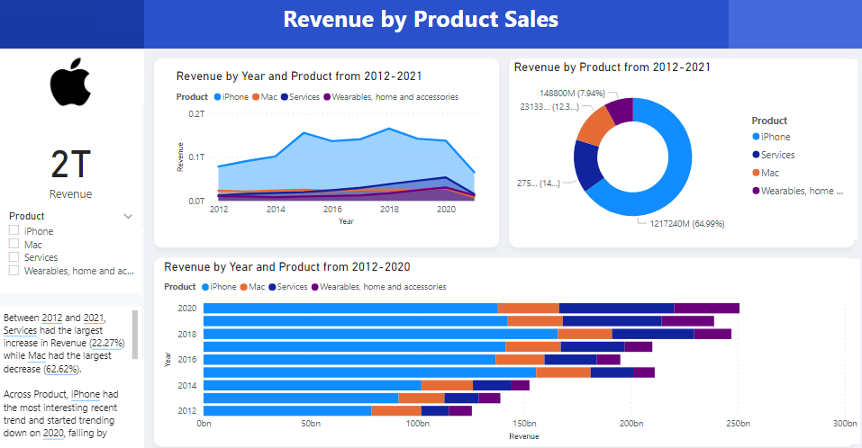

Appendix B: Smartphone Shipments by Quarter vs Competitors

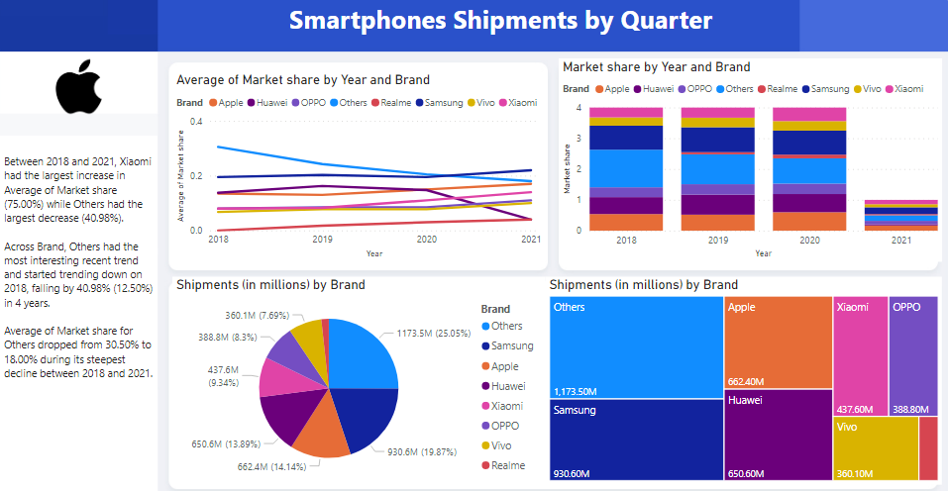

Appendix C: Revenue by Date and Region

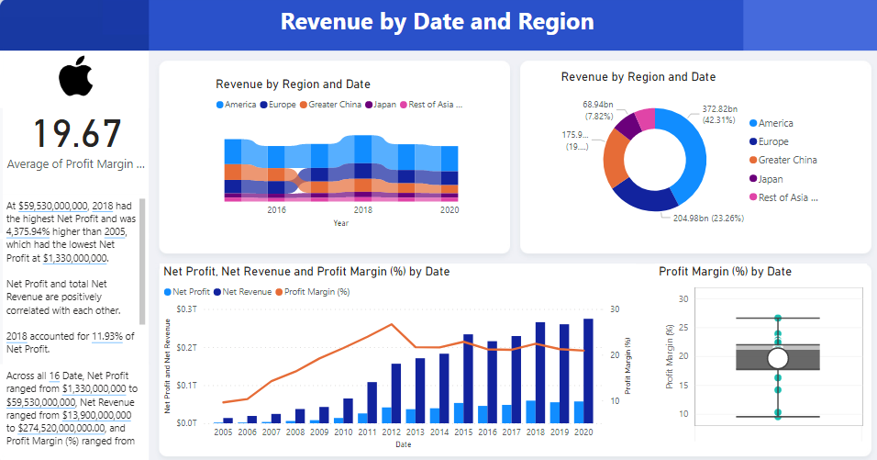

Appendix D: Smartphone Penetration Rate & 5G

